

Kgaladi Tumiso Sekgoka : ST10262964 Cornelius Eromosele : ST10302040 KUZIVAKWASHE C KANYEMBA : ST10274003 vimbainashe m mhangwa : ST10356323



ASSESSMENT TYPE: ASSIGNMENT 2

|  |  |
| --- | --- |
| **MODULE NAME** | **IT Project Management** |
| **MODULE CODE** | **IPMA6212** |
| **TEAM** | **3** |

Table of Contents

Table of figures 2

List of acronyms 3

Question 1 : Anonymous Incident Reporting App 4

Q.1.1 4

Q.1.2 5

Q.1.3 7

Question 2 0

Question 3 0

Q.3.1 0

Q.3.2 0

Question 4 0

Q.4.1 0

Question 5 0

Q.5.1 Peer Evaluation Report 0

Q.5.2 Self-Reflection Report 3

References 4

# Table of figures

Figure 1:Work Breakdown Structure (WBS) For Anonymous Incident Reporting App (draw.io, 2025). 0

Figure 2:WBS (draw.io, 2025). 1

Figure 3:WBS (draw.io, 2025). 2

Figure 4:WBS (draw.io, 2025). 3

Figure 5:WBS (draw.io, 2025). 4

Figure 6: Indentured WBS (MS Project, 2021). 1

Figure 7:Indentured WBS (MS Project, 2021). 1

Figure 8:Indentured WBS (MS Project, 2021). 2

Figure 9:Indentured WBS (MS Project, 2021) 3

Figure 10: Issues Log (GitHub, 2025). 0

Figure 11: Issues Log (GitHub, 2025). 1

Figure 12: Issues Log (GitHub, 2025). 1

Figure 13:Network Diagram (MS Project, 2021). 0

Figure 14:Network Diagram (MS Project, 2021). 1

Figure 15:Network Diagram (MS Project, 2021). 2

Figure 16:Network Diagram (MS Project, 2021). 3

Figure 17:Network Diagram (MS Project, 2021). 4

Figure 18:Network Diagram (MS Project, 2021). 5

Figure 19:Network Diagram (MS Project, 2021). 6

Figure 20:Network Diagram (MS Project, 2021). 7

Figure 21:Network Diagram (MS Project, 2021). 8

Figure 22:Network Diagram (MS Project, 2021). 9

Figure 23:Network Diagram (MS Project, 2021). 9

Figure 24:Full Network Diagram (MS Project, 2021). 10

Figure 25:Full Network Diagram (MS Project, 2021). 11

# List of acronyms

WBS - Work breakdown structure

iOS - iPhone Operating System

UI - User Interface

SMART - Specific, Measurable, Attainable, Relevant and Time bound

UAT - User Acceptance Testing

API - Application Programming Interface

# Question 1 : Anonymous Incident Reporting App

# Q.1.1

A **project evaluation form** is a structured tool used to assess the feasibility, relevance, and potential impact of a project before development begins. It plays a crucial role in determining whether a project should move forward (Nortje, 2025).

**Importance of a Project Evaluation Form:**

1. **Feasibility Assessment:**

Evaluates whether the project can be completed within the given budget (R1 750 000) and timeline (twelve months) (creately, 2024).

1. **Clear Objective Setting:**

Helps define the project’s goals, such as enabling anonymous reporting of crime and hazards to improve community safety (creately, 2024).

1. **Informed Decision Making:**

Assists stakeholders in determining whether the project aligns with the community’s needs and values (Landau, 2025).

1. **Early Risk Identification:**

Highlights potential challenges like data privacy concerns, low internet access, or user adoption, allowing for early planning (Nortje, 2025).

1. **Accountability and Planning:**

Establishes a clear foundation for the project team to follow, ensuring effective resource allocation, progress tracking, and team accountability (Landau, 2025).

**Why it is needed for this project:**

For the **Anonymous Incident Reporting App**, a project evaluation form ensures that the app will function effectively across urban, township, and rural areas. It helps confirm that the app meets essential non-functional requirements such as high **availability** and **simplicity**, making it accessible and easy to use, even in emergency situations. Additionally, the form serves to clearly document **stakeholder expectations**, ensuring that all involved parties are aligned on the goals and deliverables. Most importantly, it prioritizes **user safety** and **data confidentiality**, addressing critical concerns related to privacy and trust when users report incidents anonymously.

# Q.1.2

**Cross-platform development** refers to the practice of creating mobile applications that are compatible with multiple operating systems, such as **Android** and **iOS**, using a single codebase. This allows developers to write the app once and deploy it across various platforms, saving both time and effort compared to developing separate native apps for each platform. Cross-platform frameworks like **Flutter** enable this by providing tools to create apps that behave like native ones, without the need to replicate development for each operating system (WEQ Technologies, 2025).

**How Cross-Platform Development Will Contribute to Meeting Project Timelines:**

By adopting **Flutter** for the **Anonymous Incident Reporting App**, cross-platform development will significantly contribute to meeting the **twelve-month project timeline**. Flutter enables the use of a single codebase for both **Android** and **iOS**, which accelerates development and reduces the time spent on separate builds and testing for each platform. With Flutter, features and updates can be implemented simultaneously across both platforms, reducing the need for redundant work. This streamlined development process ensures that the app is built and tested faster, helping the project stay within the budget and timeline constraints (Jackrabbit, 2024).

**Three Potential Risks Associated with Cross-Platform Development:**

* Performance Limitations:

Despite Flutter’s performance optimizations, it may still face some limitations compared to fully native apps, especially for resource heavy tasks. For instance, real-time features like **location tracking** or media handling might not perform as efficiently on all devices, leading to potential lag or delays (Team EMB, 2023).

* Limited Access to Native Features:

While Flutter provides many native like functionalities, it may not always support the latest platform specific features or application programming interfaces (APIs) immediately. This could hinder the ability to fully integrate with advanced device specific features such as certain hardware sensors or operating system level services, which may be critical for the app’s functionality (Jackrabbit, 2024).

* Platform Specific Bugs:

Although the codebase is unified, there may still be platform specific bugs due to subtle differences between Android and iOS. These bugs could require additional testing and fixes, which may delay the app’s release or lead to inconsistencies in performance across devices (Fora Soft , 2024).

**How Cross-Platform Development Will Enhance the User Experience and Usability:**

Cross-platform development with **Flutter** will significantly enhance the **user experience** and **usability** of the **Anonymous Incident Reporting App**. Since the app will be built with a single codebase for both platforms, it will provide users with a consistent and unified experience, regardless of whether they are using **Android** or **iOS**. The **UI consistency** achieved through Flutter’s customizable widgets ensures that the app will look and behave the same across both platforms, which is crucial for emergency situations where ease of use and familiarity are essential (Rogers,Sharp, & Preece, 2019). Additionally, Flutter supports **responsive design**, ensuring the app adapts seamlessly to different screen sizes and device types, making it accessible to a wider range of users. This consistency in design and functionality across devices will enhance the app’s usability, ensuring that users can easily navigate and report incidents quickly and efficiently (Kanyama, 2025).

# Q.1.3

**Five Major Deliverables Included in the Project Charter are:**

1. **Project Scope Definition**

A clear statement outlining the purpose of the app to allow individuals to report crimes, environmental hazards, or unsafe structures anonymously, and a summary of the app’s features, such as location tracking, photo uploads, and secure report submission (Good, 2023).

1. **Project Objectives**

To establish a Specific, Measurable, Attainable, Relevant, and Time bound (SMART) goal. Develop a cross-platform mobile application, accessible even in low network areas, with a user friendly interface that supports both text and multimedia reporting. The project will be completed within a twelve month timeline and aims to improve community safety through anonymous incident reporting (geeksforgeeks, 2024).

1. **Project Schedule and Timeline**

A high level timeline that includes **monthly milestones** over the twelve month period, detailing key phases like planning, design, development, testing, and deployment (Good, 2023).

1. **Budget Allocation Plan**

An outline of how the **R1 750 000** budget will be distributed across resources such as hiring developers, designers, testers, infrastructure, marketing, and contingency funds (Nortje, 2025).

1. **Risk Management Strategy**

A preliminary list of potential risks (for example, data breaches, development delays, low user adoption) and the mitigation plans for each, to ensure smooth project execution (geeksforgeeks, 2024).

# Question 2

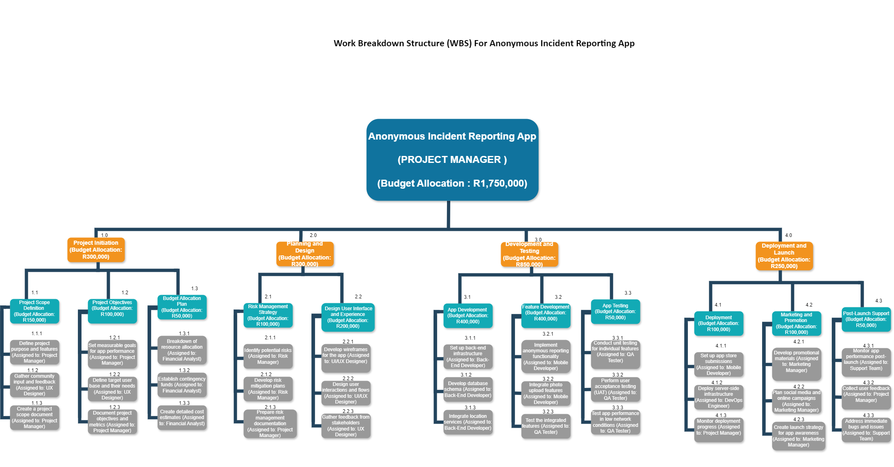

Figure 1:Work Breakdown Structure (WBS) For Anonymous Incident Reporting App (draw.io, 2025).

Figure 2:WBS (draw.io, 2025).

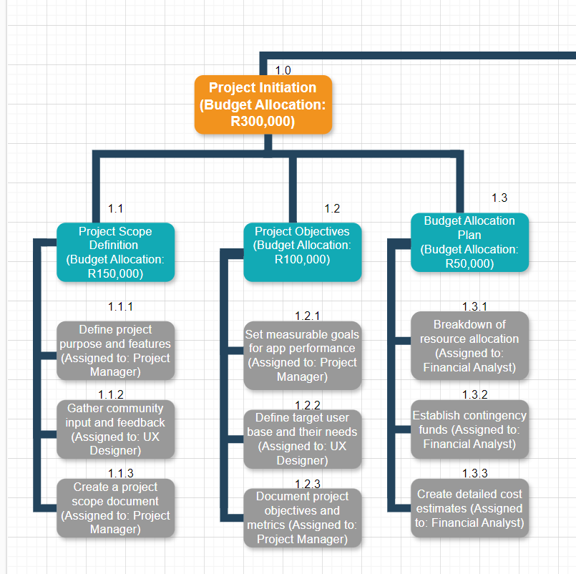

Figure 3:WBS (draw.io, 2025).

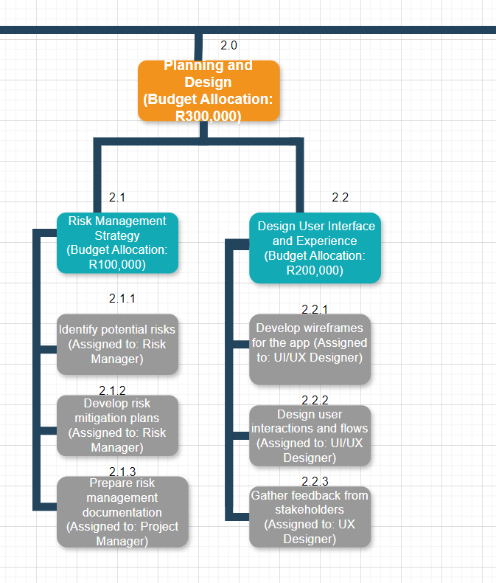

Figure 4:WBS (draw.io, 2025).

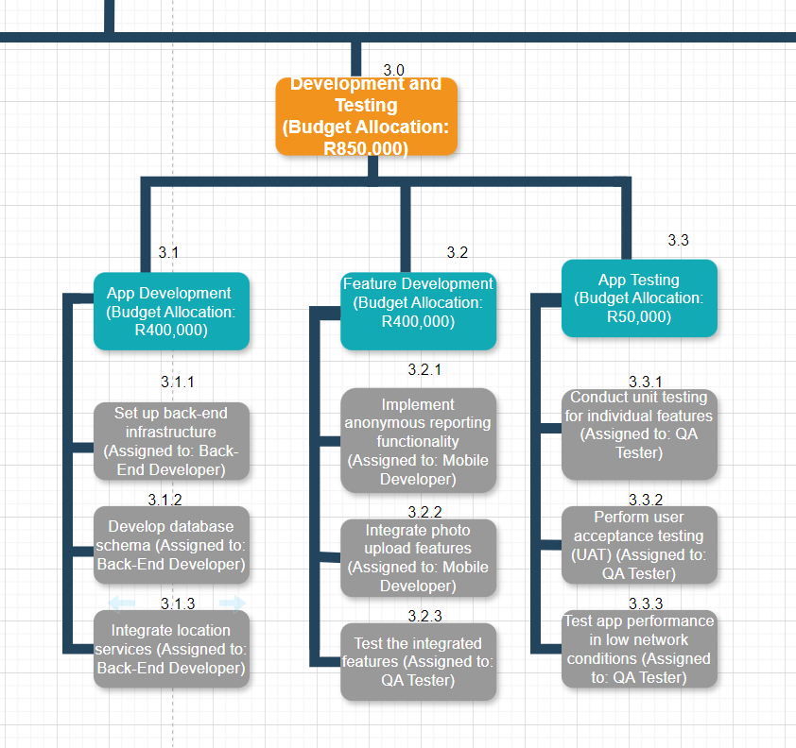

Figure 5:WBS (draw.io, 2025).

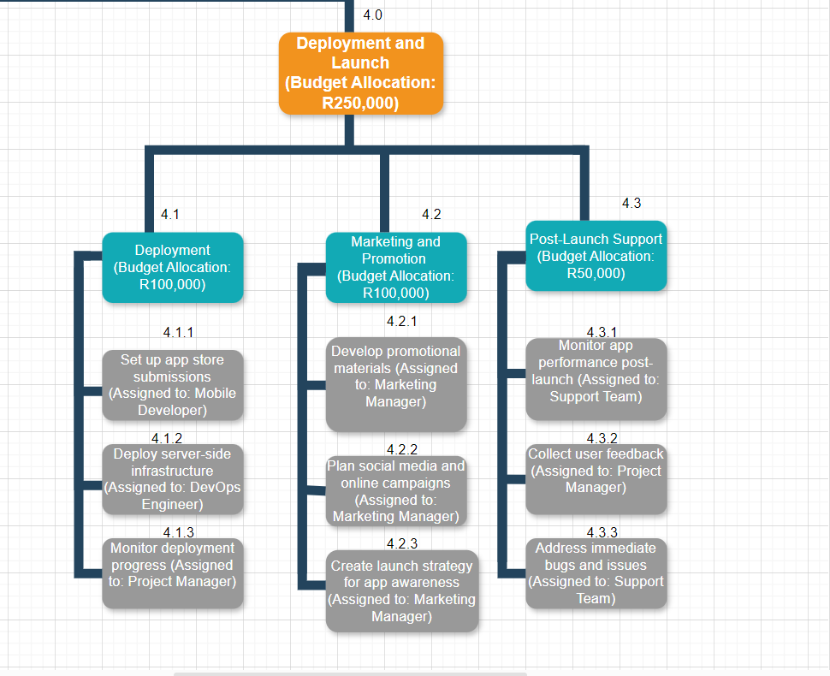

# Question 3

# Q.3.1

Figures 6 to 9 illustrate the indentured list derived from the Work Breakdown Structure (WBS) for the **Anonymous Incident Reporting App**.

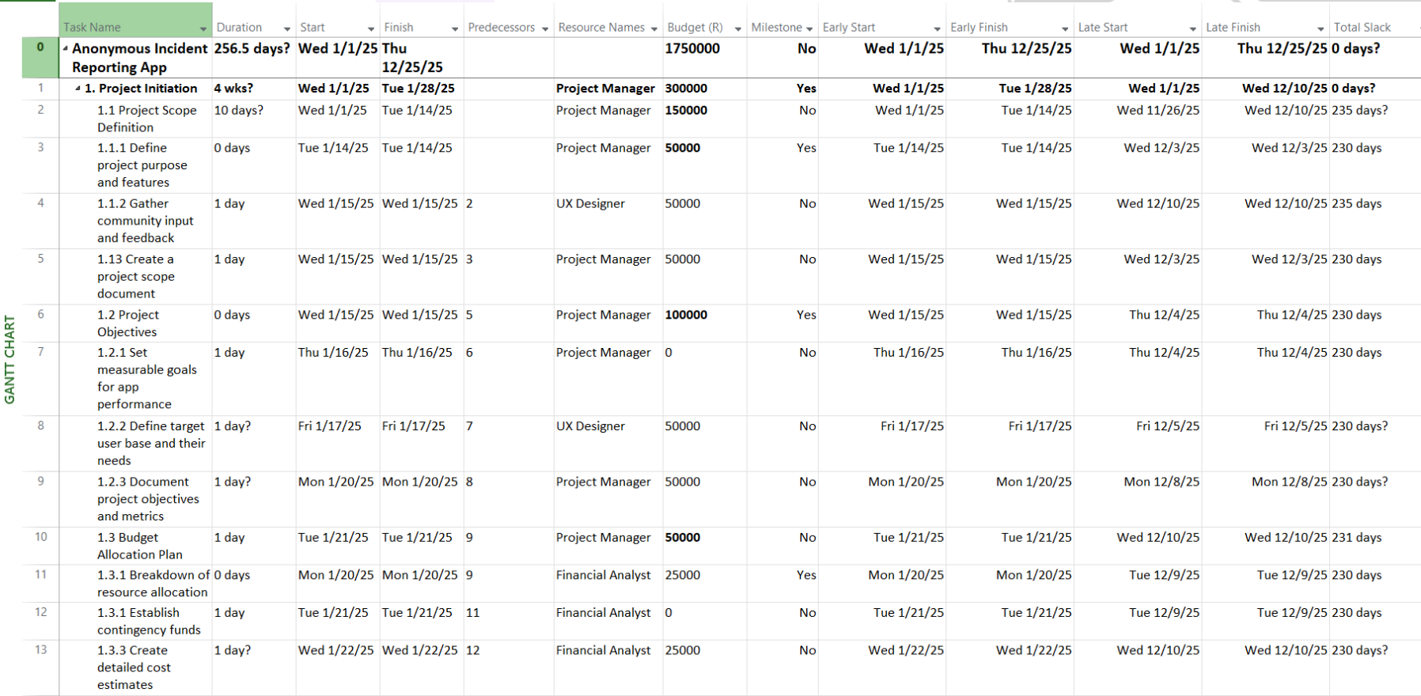

Figure 6: Indentured WBS (MS Project, 2021).

Figure 7:Indentured WBS (MS Project, 2021).

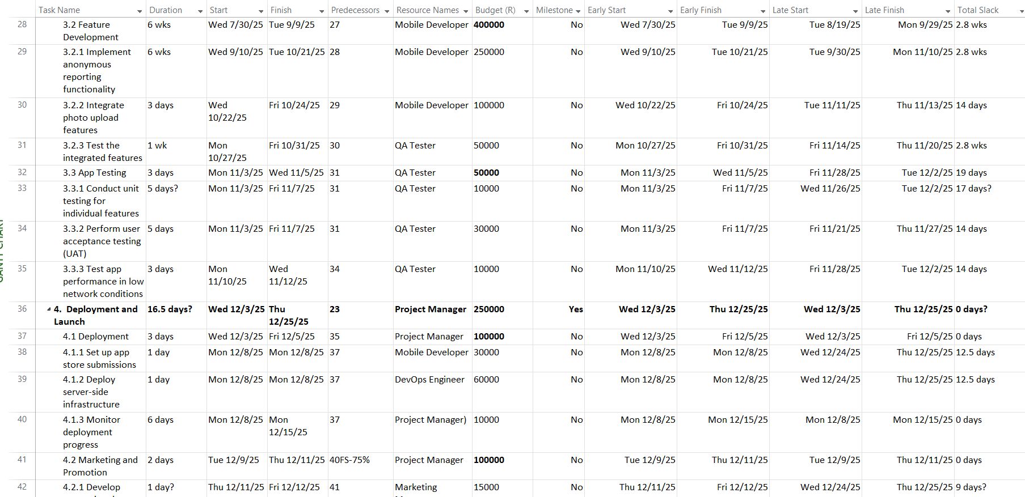

Figure 8:Indentured WBS (MS Project, 2021).

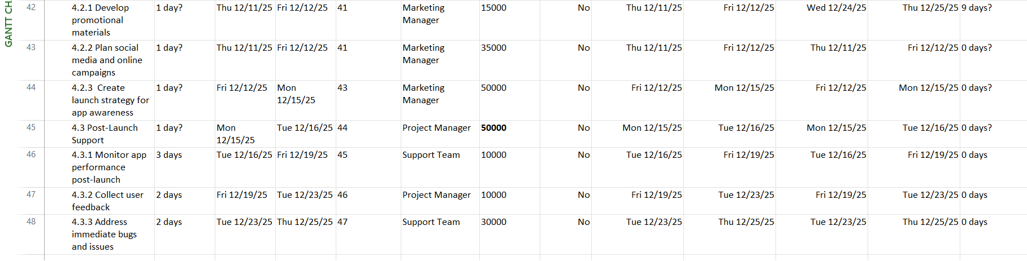

Figure 9:Indentured WBS (MS Project, 2021)

# Q.3.2

**Below is the link to the repository:**

<https://github.com/users/KgaladiTumisoSekgoka/projects/1/views/1>

**Screenshots of the issues log:**

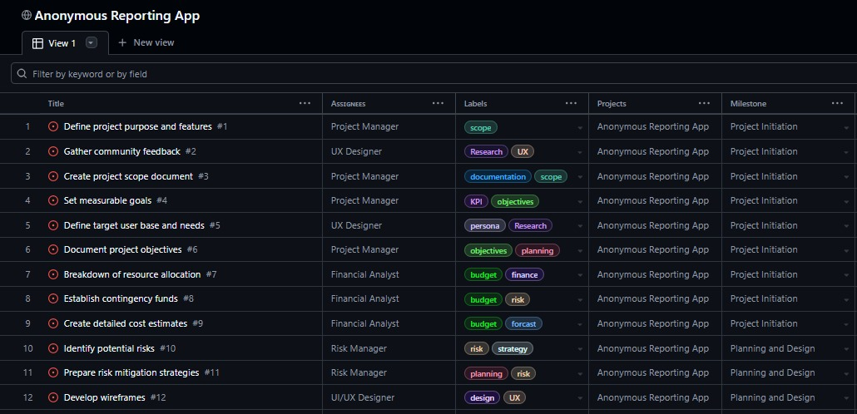

Figure 10: Issues Log (GitHub, 2025).

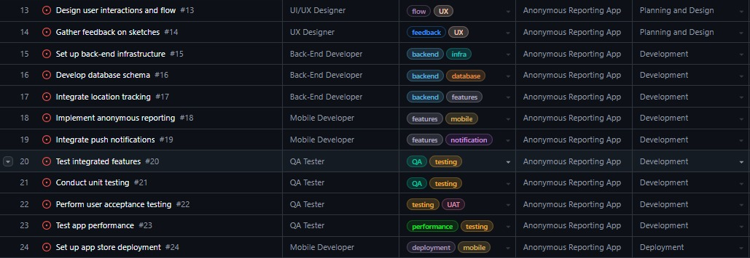

Figure 11: Issues Log (GitHub, 2025).

Figure 12: Issues Log (GitHub, 2025).

# Question 4

# Q.4.1

Figures 13 to 23 present the detailed network diagrams for the Anonymous Incident Reporting app, while Figures 24 and 25 display the complete network diagram:

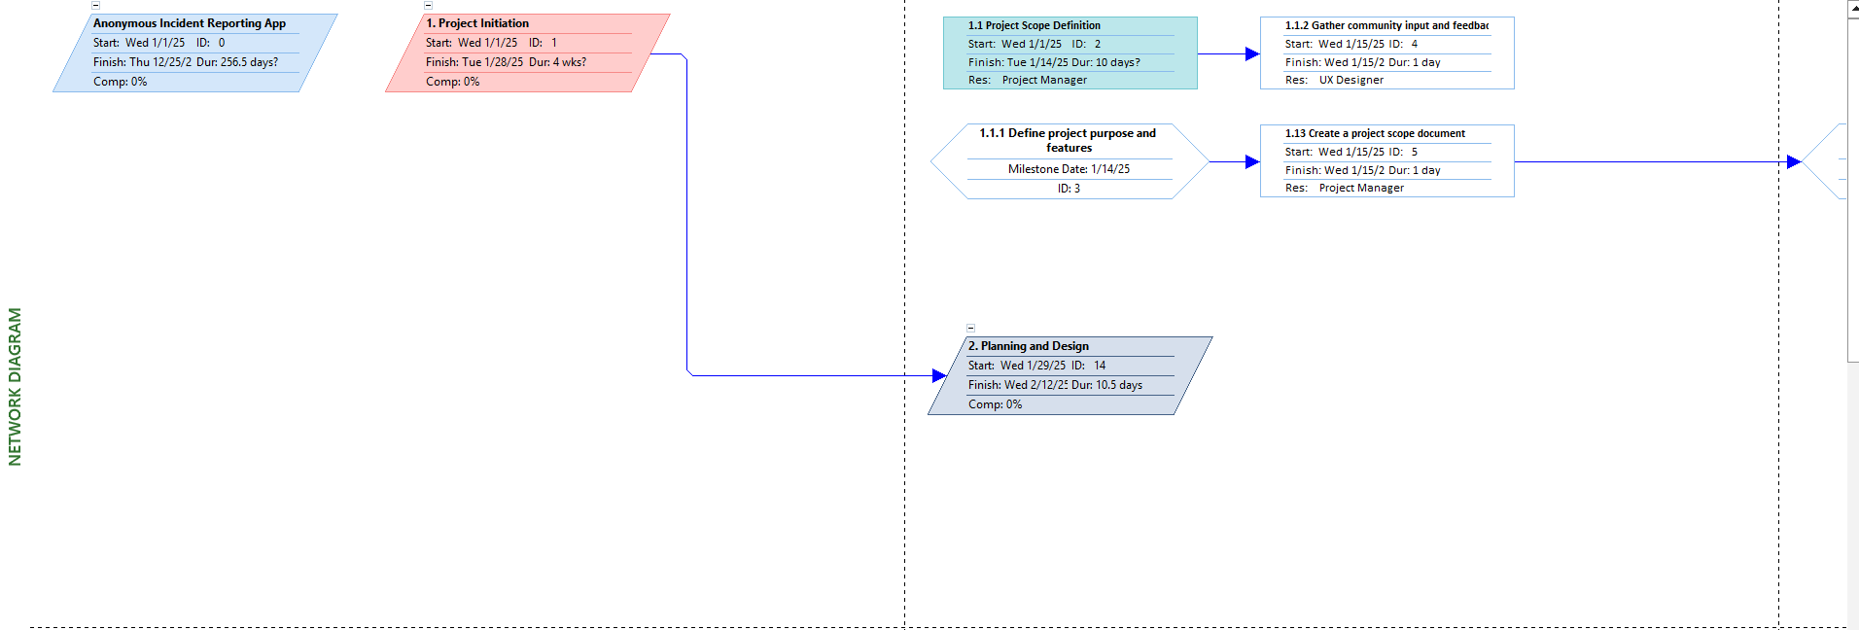

Figure 13:Network Diagram (MS Project, 2021).

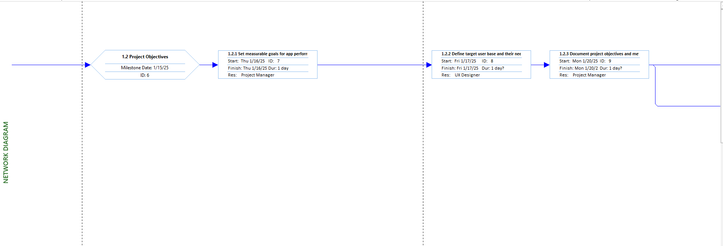

Figure 14:Network Diagram (MS Project, 2021).

Figure 15:Network Diagram (MS Project, 2021).

Figure 16:Network Diagram (MS Project, 2021).

Figure 17:Network Diagram (MS Project, 2021).

Figure 18:Network Diagram (MS Project, 2021).

Figure 19:Network Diagram (MS Project, 2021).

Figure 20:Network Diagram (MS Project, 2021).

Figure 21:Network Diagram (MS Project, 2021).

Figure 22:Network Diagram (MS Project, 2021).

Figure 23:Network Diagram (MS Project, 2021).

Figure 24:Full Network Diagram (MS Project, 2021).

Figure 25:Full Network Diagram (MS Project, 2021).

# Question 5

# Q.5.1 Peer Evaluation Report

|  |  |  |  |  |  |  |
| --- | --- | --- | --- | --- | --- | --- |
|  | **Name of student being evaluated:** | | | | |  |
|  | | Seldom  0 | Frequently  1 | Always  2 |
| **The student’s personal work:** | |
| 1  . | The student contributed good ideas that added value to the project and produced high quality work. |  |  |  |
| 2  . | The student performed their tasks in line with what was expected of them. |  |  |  |
| 3  . | The student managed their own time well and met deadlines. |  |  |  |
| **The student’s work as part of a team:** | | | | |
| 4  . | The student accepted responsibility for a fair portion of the tasks and was an enthusiastic member of my team. |  |  |  |
| 5  . | The student helped others to be successful and worked well with other members of the team. |  |  |  |
| **Weighting** | |  |  | 10/2 |
| Total /5 | | | | |

|  |  |  |  |  |  |  |
| --- | --- | --- | --- | --- | --- | --- |
|  | **Name of student being evaluated:** | | | | |  |
|  | | Seldom  0 | Frequently  1 | Always  2 |
| **The student’s personal work:** | |
| 1  . | The student contributed good ideas that added value to the project and produced high quality work. |  |  |  |
| 2  . | The student performed their tasks in line with what was expected of them. |  |  |  |
| 3  . | The student managed their own time well and met deadlines. |  |  |  |
| **The student’s work as part of a team:** | | | | |
| 4  . | The student accepted responsibility for a fair portion of the tasks and was an enthusiastic member of my team. |  |  |  |
| 5  . | The student helped others to be successful and worked well with other members of the team. |  |  |  |
| **Weighting** | |  |  | 10/2 |
| Total /5 | | | | |

|  |  |  |  |  |  |  |
| --- | --- | --- | --- | --- | --- | --- |
|  | **Name of student being evaluated:** | | | | |  |
|  | | Seldom  0 | Frequently  1 | Always  2 |
| **The student’s personal work:** | |
| 1  . | The student contributed good ideas that added value to the project and produced high quality work. |  |  |  |
| 2  . | The student performed their tasks in line with what was expected of them. |  |  |  |
| 3  . | The student managed their own time well and met deadlines. |  |  |  |
| **The student’s work as part of a team:** | | | | |
| 4  . | The student accepted responsibility for a fair portion of the tasks and was an enthusiastic member of my team. |  |  |  |
| 5  . | The student helped others to be successful and worked well with other members of the team. |  |  |  |
| **Weighting** | |  |  | 10/2 |
| Total /5 | | | | |

# Q.5.2 Self-Reflection Report

**Introduction**

**Skills Learnt**

**Role in the Team**

**Research and Technology**

**Personal Strengths and Weaknesses**

**Stakeholder Relationships**

**Impact**

**Conclusion**

# References

creately, 2024. *What is Project Evaluation? The Complete Guide with Templates.* [Online]   
Available at: https://creately.com/guides/project-evaluation/  
[Accessed 22 April 2025].

draw.io, 2025. s.l.:s.n.

Fora Soft , 2024. *Is Cross-Platform App Development with Flutter Worth It? Pros, Cons, and Key Insights.* [Online]   
Available at: https://www.forasoft.com/blog/article/cross-platform-app-development-flutter-pros-cons  
[Accessed 22 April 2025].

geeksforgeeks, 2024. *Phases of Project Management Process.* [Online]   
Available at: https://www.geeksforgeeks.org/phases-project-management-processes/  
[Accessed 22 April 2025].

GitHub, 2025. *Anonymous Incident Reporting App.* [Online]   
Available at: https://github.com/users/KgaladiTumisoSekgoka/projects/1/views/1  
[Accessed 24 April 2025].

Good, L., 2023. *What is a Project Charter? Complete Guide & Examples.* [Online]   
Available at: https://project-management.com/what-is-a-project-charter/  
[Accessed 22 April 2025].

Jackrabbit, 2024. *Cross-Platform App Development 2025: Trends, Benefits, and Best Practices.* [Online]   
Available at: https://www.jackrabbitmobile.com/blog/cross-platform-app-development-2025-trends-benefits-and-best-practices/  
[Accessed 22 April 2025].

Kanyama, Y., 2025. *Lecture Slides.* s.l.:Unpublished.

Landau, P., 2025. *Project Evaluation Process: Definition, Methods & Steps.* [Online]   
Available at: https://www.projectmanager.com/blog/improving-project-evaluation-process  
[Accessed 22 April 2025].

MS Project, 2021. s.l.:s.n.

Nortje, H., 2025. *Lecture Slides.* s.l.:Unpublished.

Rogers,Sharp, & Preece, 2019. *Interaction Design: Beyond Human Computer Interaction.* 5th ed. Indianapolis: John Wiley & Sons,Inc.

Team EMB, 2023. *Cross-Platform app development: Pros, Cons, and Tools.* [Online]   
Available at: https://blog.emb.global/cross-platform-app-development/#:~:text=Cons%20of%20Cross-Platform%20App%20Development%201%20Limited%20Access,Challenges%20...%208%20Fragmented%20Ecosystem%20...%20More%20items  
[Accessed 22 April 2025].

WEQ Technologies, 2025. *Cross-Platform App Development: 2025 Trends & Beyond.* [Online]   
Available at: https://weqtechnologies.com/cross-platform-app-development-2025-trends-beyond/#:~:text=Explore%20the%20latest%20trends%20in%20cross-platform%20app%20development,IoT%20integration%2C%20and%20improved%20performance%20across%20multiple%20platforms.  
[Accessed 22 April 2025].